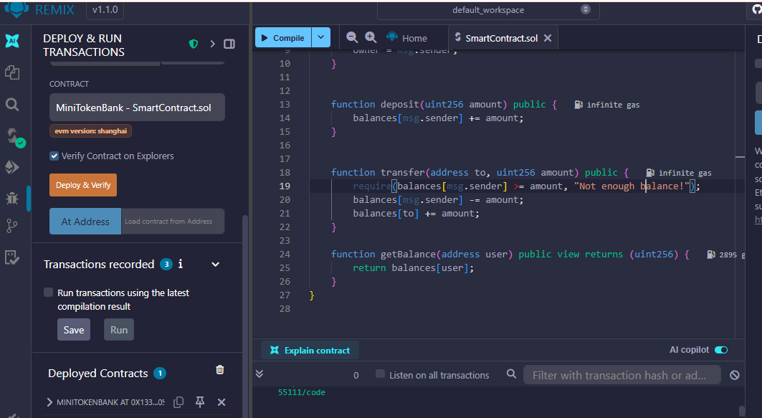
1.Deployed Contract on Remix
Contract address:
0x133C8f9C035570afF3d6e27748785A0D6f205A5c

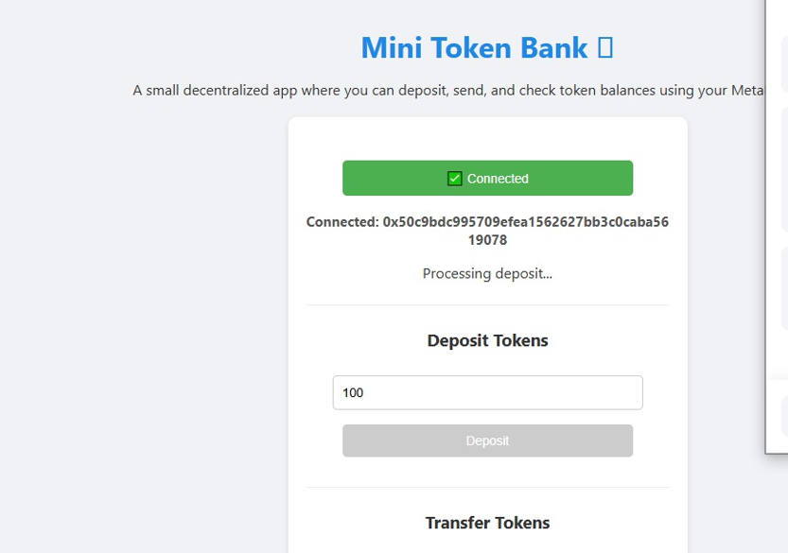
2.dApp connected to Metamask successfully

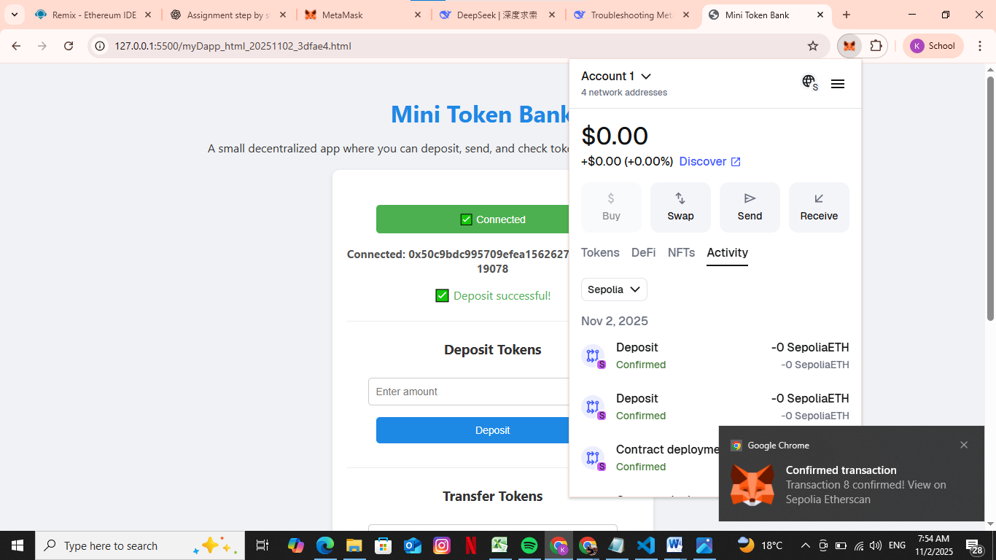
3-Successful transaction

